# Results

## 2D vs 3D results comparison

Figure 1 2D vs 3D simulation

From the above scalar field strength, we can see that even though the geometry is changed from 2 dimensional to 3 dimensional, the resulting EM field distribution remain unchanged roughly the same. This proves that the 2D simulation is a valid approximation for 3D simulation in this special case of EM field distribution.

## Resolution

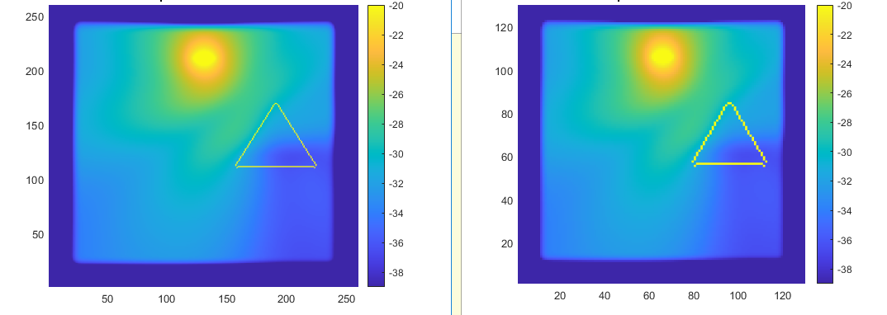

Figure 2 different resolution effect on the results

From the above figure, we can see that even though we reduced the resolution from 30 cells/unit to 15 cells/unit, it produces same EM field distribution. From this, we can conclude that the 15 cells/unit resolution is sufficient to produce accurate results.

Simulation resolution setup:

The frequency of the wave and slice of time data taken play an important balance for the accuracy of the output EM field strength. As the complex shape of the geometry transform the wave non-linearly.

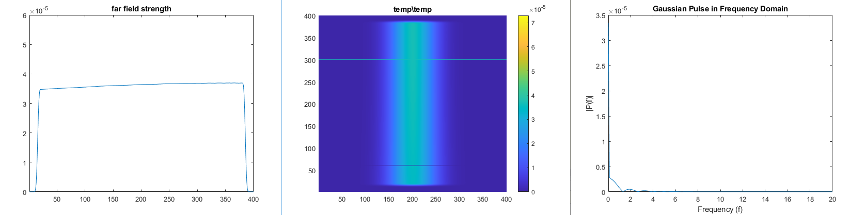

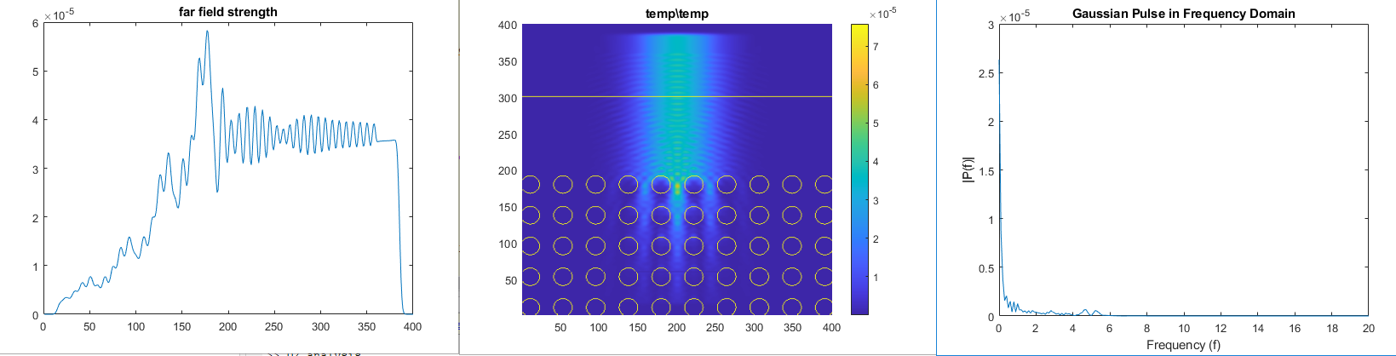

## Incident & reflective spectrum

Computing reflection spectra requires some care because we need to separate the incident and reflected fields. Firstly, save the Fourier-transformed fields from the normalization run. Then latter subtracts the incident fields from the scattered fields.

Second time, we need to reset Meep and redefine geometry and structure.

Different interface roughness will contribute to different amount of absorbed, reflected field.

## Meep units and nonlinearities

MEEP is inherently unitless. 0.1 cm/cell has been chosen for the geometry. As a result, a 2.54GH source is 0.8167 wavelength. The geometry correspond well with the size of the actual device in the real application.

## Simple geometry results

## Shape influence on the wave shape

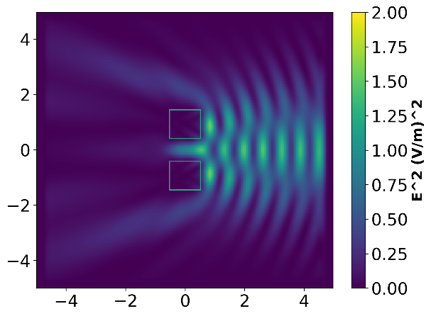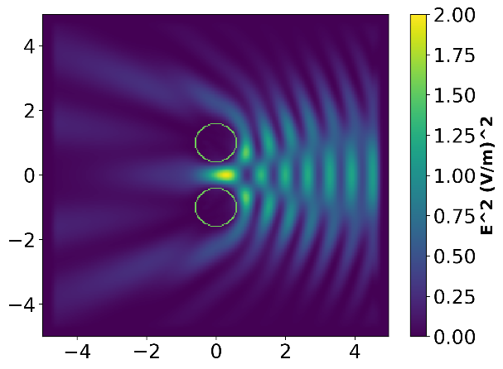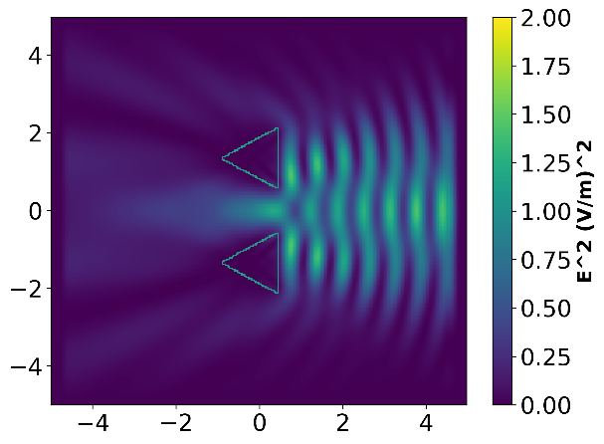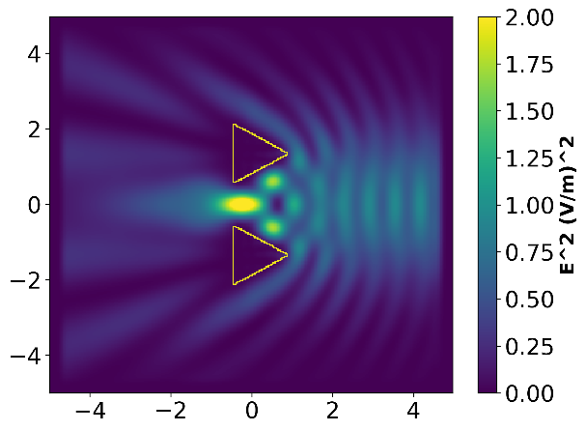

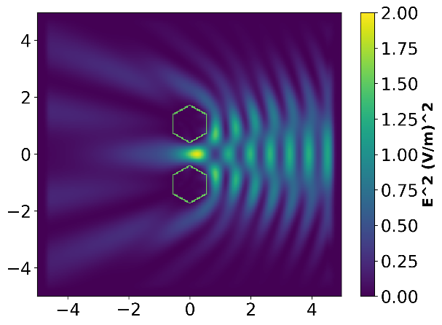

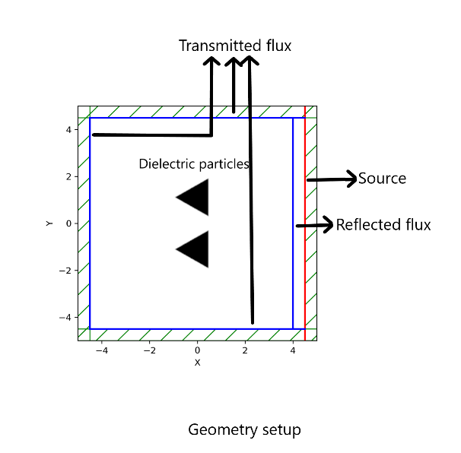

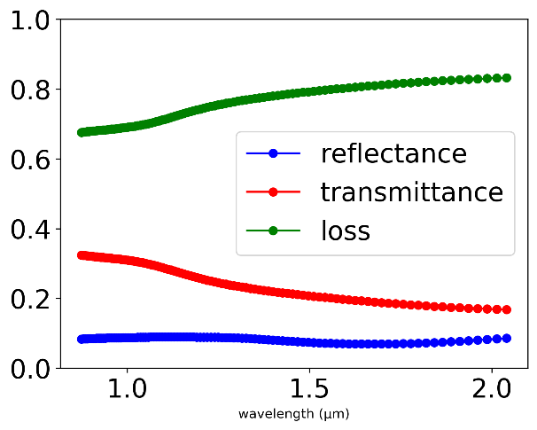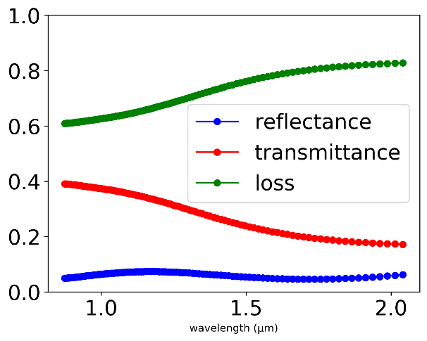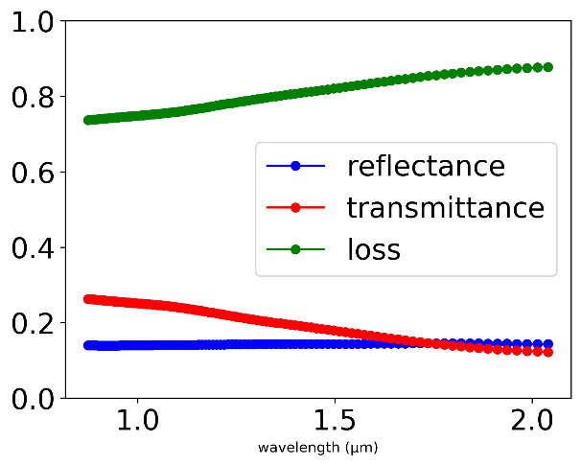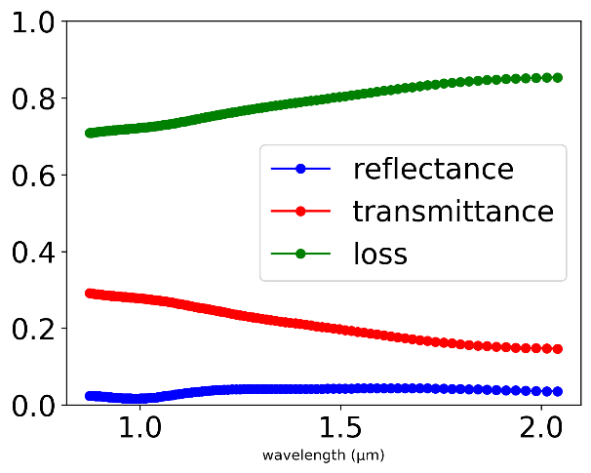

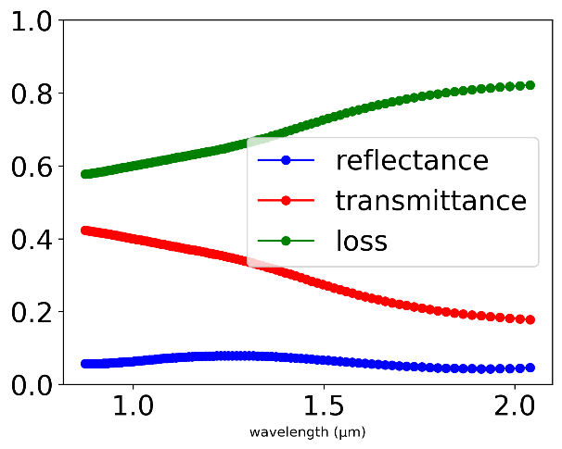

In the experiment setting, the size of the particle is kept constant. The spacing between them is kept constant as well, to ensure the comparison are valid.

The edge of the particles will also shape the EM wave. It can be seen the middle between two triangles and spheres concentrated high intensity of EM wave due to the fact that they have they have edges that focuses the EM source.

The sharper the include edge, the high strength the field in the center is.

Comparing the square particle and triangle particle, we can see that they have similar reflective pattern due to they have similar geometry shape facing the source.

The flux data around the simulation area is also collected and analyzed. Due the similar size of the particles, the same absorption is discovered. This indicate that the most important factor in wave energy absorption is the size of absorption particle. However, varying geometry results in different transmittance and relectance. We can see that the third setup have the highest relectance. This is due to the fact that the particle face towards the source are the largest amongst all setups. The 4th setup has the lowest absorption due to the fact that the it has the smallest faces towards the source of the Microwave.

It is suspect that the reason behind the difference in the amount of transmitted light are the sharper the edge, the more interference is caused at the edge, which results in more absorption at those edges.

**Why, and how to predict.**

## The shape particle internal strength profile

The EM field strength is extracted and graphed in the bottom.

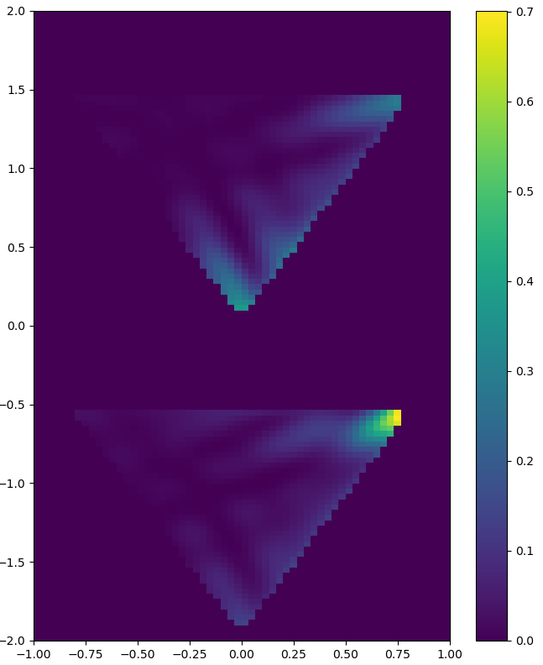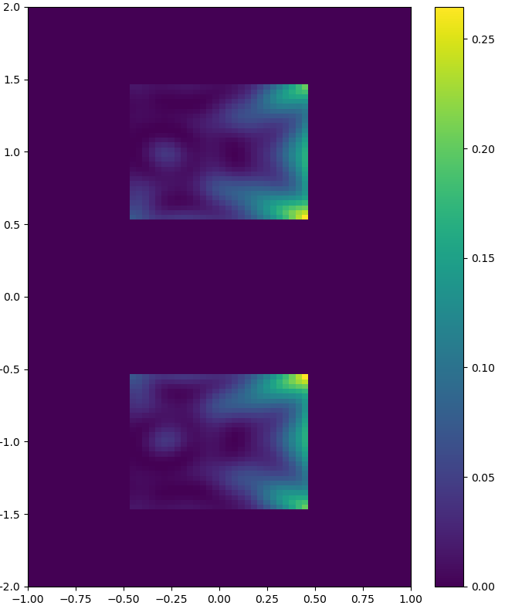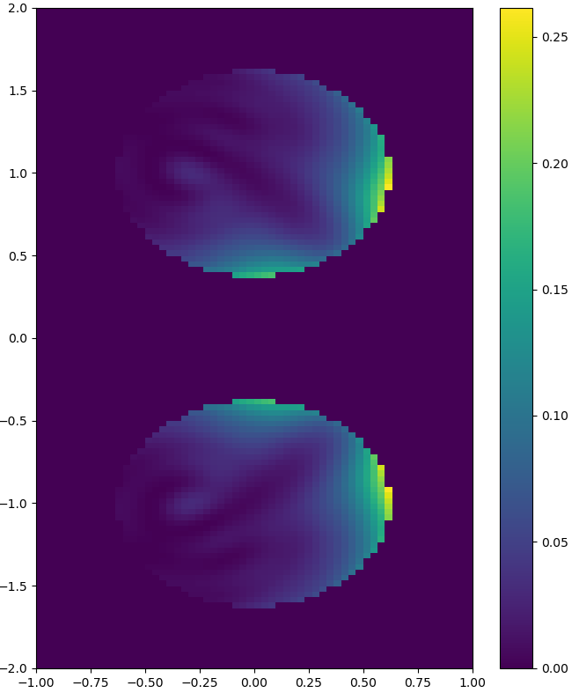

In the colormap above, only the particles locations

Corner

Superposition

Situation (corner to surface and corner to corner)

Different gap size. Graph relationship.

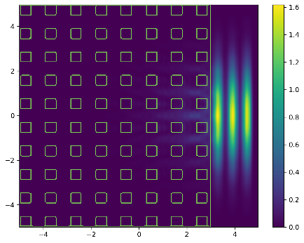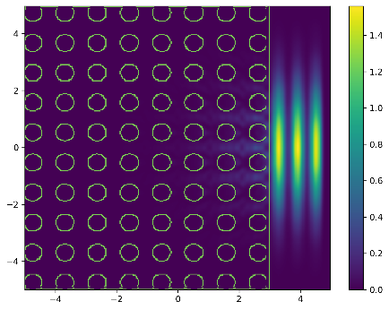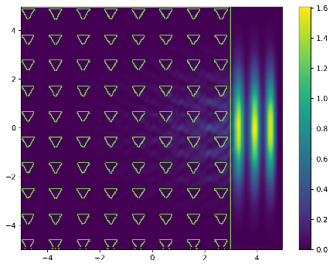

### Checker

## Size

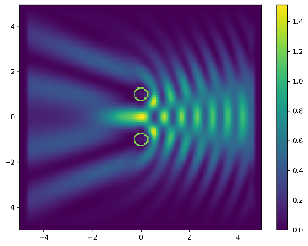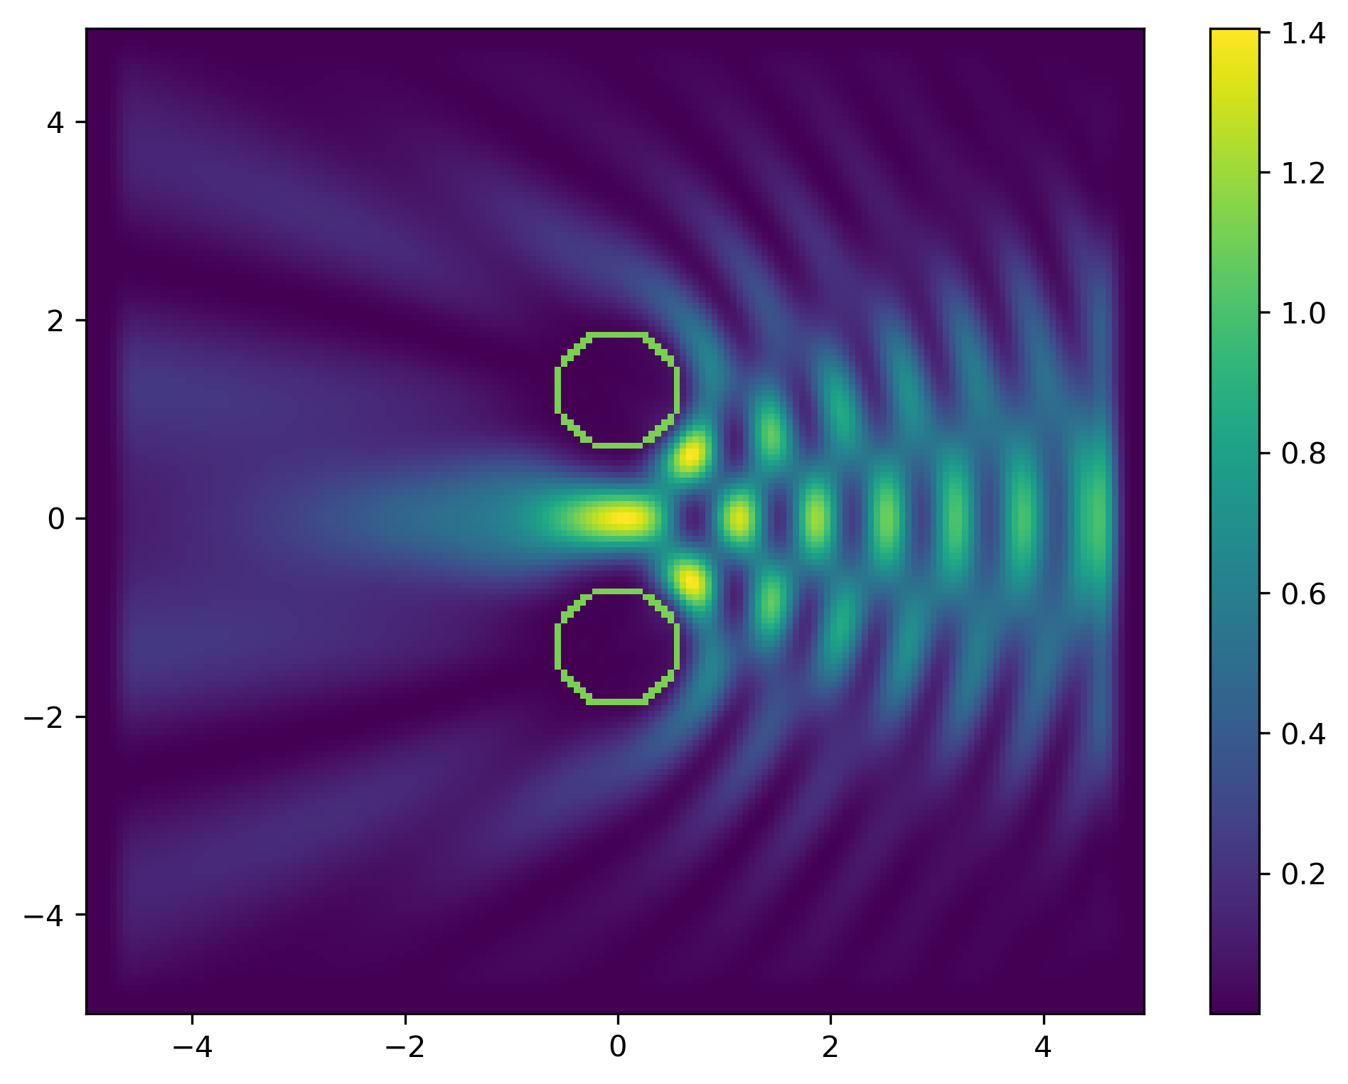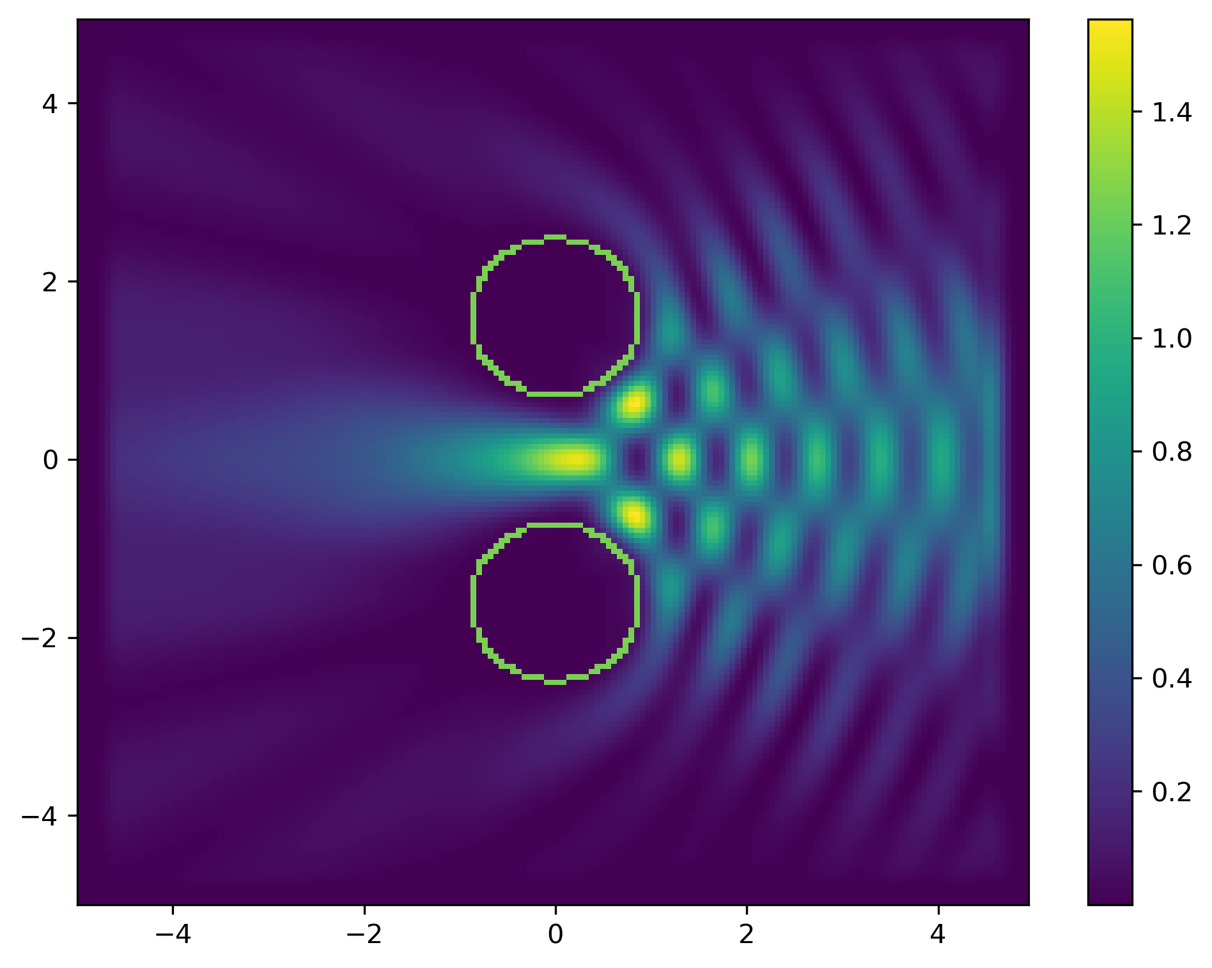

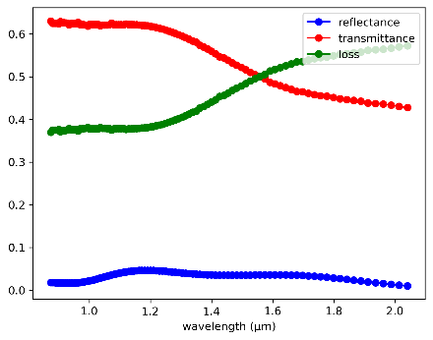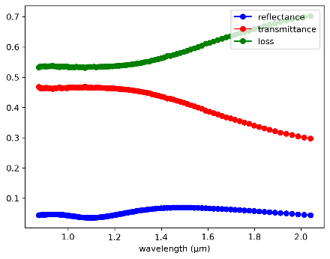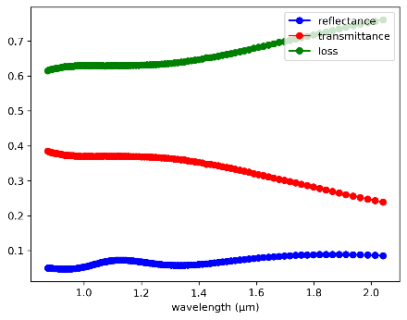

From left to right, the radius of the sphere increased from 0.3 cells, to 0.9 cells.

From the color scales of the graph, conclusion can be drawn that the size of the sphere significantly reduced the transmitted EM wave strength.

The corresponding transmission flux energy confirms the hypothesis. It can be see that as the radius of the sphere increases, the loss at center frequency increased from 0.45 to 0.65. The amount of reflection shows significant increase as well.

Gap is kept constant at 1.4 cells.

### Relative to wavelength

### Critical size formula

## Spacing or channel for light

### Relative to wavelength

## Filling factor

## Anisotropic inhomogeneous dielectric constant